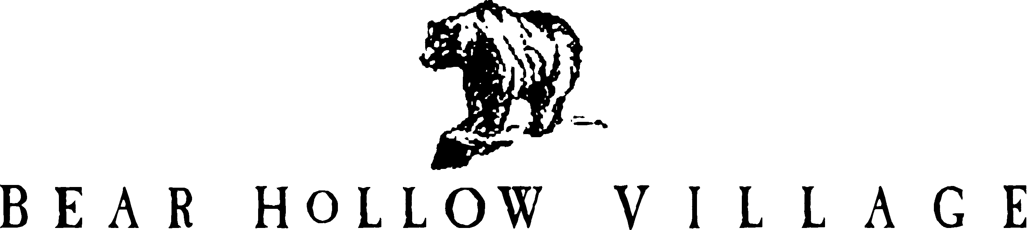

HOMEOWNER’S ASSOCIATION
PARK CITY, UTAH

2023 BOARD OF TRUSTEES

HOWARD E. BUTT - TRUSTEE / PRESIDENT

JOSEPH LODRICK - TRUSTEE /VICE PRESIDENT/ TREASURER

KAREN MALM – TRUSTEE

JOHN MOLENAAR - TRUSTEE

SUBORDINATE OFFICERS OF THE ASSOCIATION

PATRICIA M. BUTT - ASSISTANT SECRETARY / TREASURER

STEVE LOTFI - WEBMASTER

