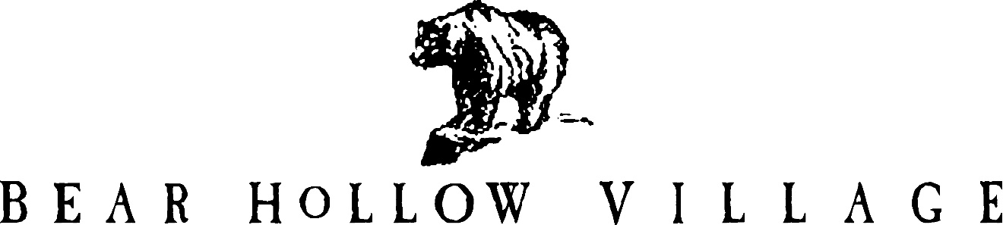

HOMEOWNER’S ASSOCIATION

PARK CITY, UTAH

NEWSLETTER

FALL 2019

This is the 45th edition of the Bear Hollow Village Homeowner’s Association Newsletter brought to you by your Board of Trustees. This Newsletter will provide you with an update on things happening in our community and other information.

**\*\*\*\*\*\*\*\*\*\*\*\*\*\*\*\*\*\*\*\*\*\*\*\*\*\*\*\***

**SUMMIT COUNTY SIDEWALK AND PAVING PROJECT**

Summit County is almost complete with their project to modify the sidewalks along Bobsled Blvd. and Oslo Lane (both County roads) to make them ADA compliant and then re-pave the roads. Sidewalk modifications and road resurfacing are completed; some cleanup and irrigation system repairs are pending. Here are some photos showing the work done….

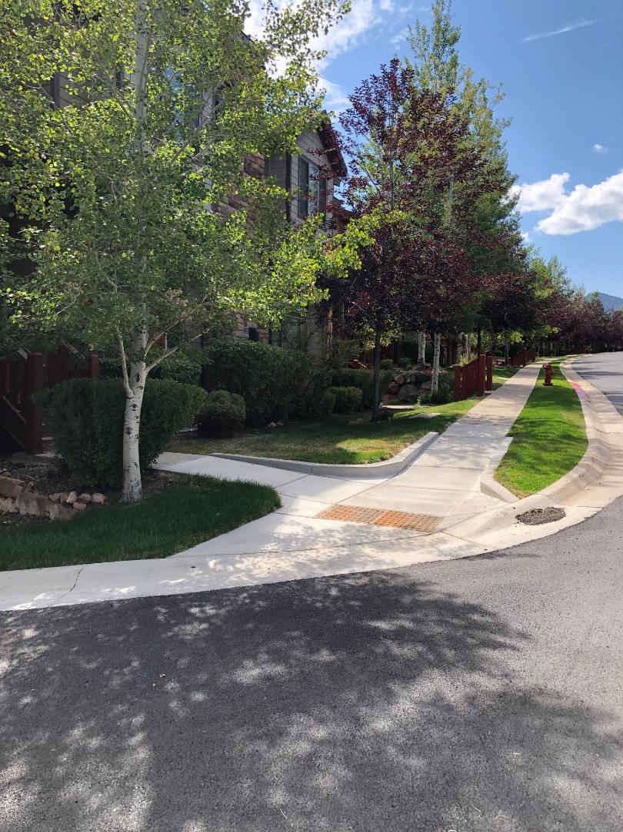

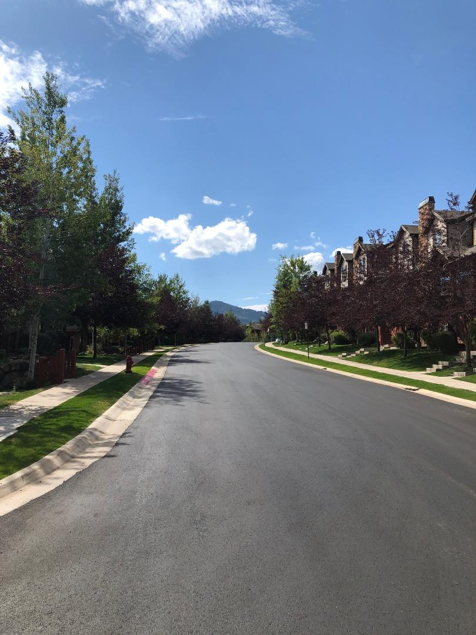

The Trustees are inspecting our private roads and obtaining estimates from paving companies to have our roads resurfaced. We may run out of time to get this done in 2019 due to weather and scheduling. If that happens, the repaving will be a priority for Spring 2020.

**ASSOCIATION FINANCES**

We are in excellent financial shape. We have the following funds on deposit with Chase Bank:

RESERVE FUNDS - $ 441,656.55

EMERGENCY FUNDS - $ 50,415.88

CHECKING ACCOUNT - $ 29,065.67

TOTAL FUNDS (as of 9/18/2019) **$ 521,138.10**

**PRIVATE PROPERTY / COMMON AREAS**

Bear Hollow Village is not a condominium community; we are a planned unit development (PUD). Each owner holds deed to their property in fee simple deed, and this is your private property. The common areas of the community are also owned in fractional share by each owner and this ownership is also reflected on your deed. (Note: the condominium units in the community are owned as part of a standard condominium ownership relationship).

Individual owners are responsible for their private property, and the HOA, on behalf of all the owners, is responsible for the common areas.

The common areas of the community (the Clubhouse, park areas, Village Green, the private roads, native areas, etc.) are for the use and enjoyment of all our residents.

The private property rights of each individual owner must be recognized and respected. We are a densely configured community and sometimes the easiest way to get from point to point is thru

someone’s private property area. All residents should refrain from this type of activity and allow each owner to enjoy the privacy their property affords to them.

Thank you in advance for your understanding and cooperation with this request.

**TRUSTEE RESIGNATION**

Trustee David Goldberg, who has served the community for many years, has sold his townhome, and he and his wife Leanne are moving on to the next phase of their lives with a move to Bluffton, South Carolina where they are building a new home in a private, lakefront community.

They also plan to visit Park City often, especially during ski season, and summers too. Their motorhome will stay in Heber, Utah and be available to them whenever needed.

On behalf of the entire community, we thank David for his excellent service and dedication to Bear Hollow Village. We wish David and Leanne safe travels, health, and happiness

in all their future plans.

In accordance with the CCR’s and By-Laws, the Trustees have appointed owner Doug Wagner a Trustee on an interim basis to serve the remainder of David’s term.

**CLUBHOUSE – POOL - HOT TUB**

After 20 years of hard water and hard use…the HOA contracted to have the pool and hot tub perimeters stripped and refinished to their original accented finish. The work was scheduled for early April prior to the pool opening. Unfortunately, the weather did not cooperate and rainy days in April and May pushed the work into June causing the pool and hot tub to be closed for four days so the work could proceed in a safe environment. The finished product looks fabulous!

A few days before the Labor Day weekend (bad timing for sure), the heat exchanger in the boiler servicing the hot tub cracked and ceased working. Recently enacted Utah State stricter boiler heat exchanger regulations mandated that we special order a new ‘compliant’ heat exchanger directly from the manufacturer. The new Utah State compliant heat exchanger was received by Dolphin Pools, our pool servicing company for many years, and installed, allowing the community to again enjoy the hot tub for the remaining days of summer.

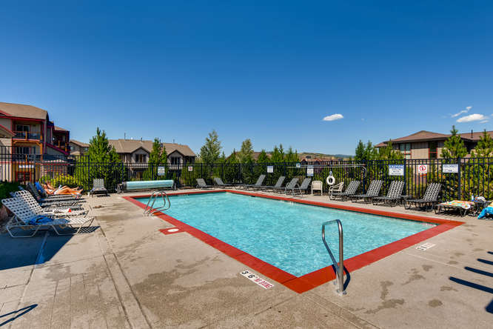

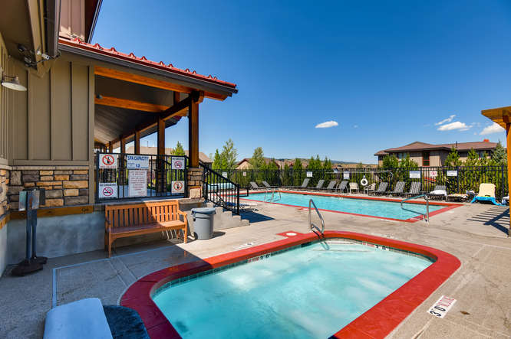

The pool will close for the season on September 22.

The hot tub remains open all year, weather permitting.

**IRRIGATION SYSTEM SHUT DOWN**

The irrigation system is being shut down in preparation for winter. Our landscape services contractor (Eschenfelder Landscape / formerly Red Barn) will close all outside valves and blow out the lines commencing October 6, 2019. All owners who have an irrigation control valve inside their home have received a separate notice from the HOA with instructions to turn that valve off.

**GET READY FOR WINTER**

The HOA recommends that all owners take this opportunity to evaluate their homes safety and winter readiness and take repairs/precautions as needed. Here are a few suggestions to consider…

* Add heat tape/ice melt panels to roof edges and gutters/downspouts
* Check attic areas to ensure roofs are properly ventilated (to prevent ice dams)
* Have your fire sprinkler system in your home checked and serviced to make sure it is properly filled with anti-freeze substance and working properly (this may be an insurance policy requirement, and if not done, it may void your policy – check with your agent.)

**UPPER LUGE LANE**

There is a turnaround / bump-out area on Upper Luge Lane. This area is a turnaround for emergency vehicles (like a fire engine or ambulance) and service vehicles (like the garbage truck) and is NOT a parking area. Residents on Upper Luge Lane are asked to please not park their vehicles in this area accordingly.

**RECYCLING - TRASH COLLECTION**

Household trash collection services are provided by Republic Services. Trash and recycling services are provided by the County and paid for as part of your property tax. The County has provided all properties / owners with a trash container. Only trash put in the container is picked up on our regularly scheduled collection day - Tuesday weekly. Trash placed outside the container will not be picked up.

Summit County also provides curbside recycling for our community and a specific recycling container is also provided. You must NOT co-mingle trash with recyclables, it will not be picked up and creates a nuisance / mess in the community. All owners / residents are asked to familiarize themselves with trash and recycling rules and follow the guidelines established.

For your information and convenience, some trash and recycling information flyers are attached to this newsletter. Please consider posting them in your garage or appropriate area as a reminder

of the guidelines to be followed.

**PARKING RULES**

We have parking rules to ensure the safety of the community. Signs are posted on all

roadways advising what the parking rules are for that area. Owners are also reminded it is

a violation of the parking rules, and the Summit County Parking Ordinance, to leave vehicles

parked unattended in the same location for more than 72 hours. The HOA does not like to have to tow a vehicle, but we also cannot permit vehicles parked in clear violation of parking rules to remain in their location. We take all reasonable measures to attempt to locate a vehicle owner

before towing, which is a last resort. However, any vehicle creating a safety concern will be towed immediately.

Also, please be reminded that Bobsled Blvd. and Oslo Lane are County roads and the Sheriff

enforces parking rules on those streets; all other roads in the community are private roads controlled by the HOA.

All community parking rules and regulations can be viewed on our website - www.bhvhoa.com

PLEASE obey the parking rules!

**HOA DESIGN REVIEW COMMITTEE**

Please be reminded that anything that will change the exterior of your property must be submitted to and reviewed / approved by the HOA Design Review Committee (DRC) as a first step. Send information describing the proposed project to any of your Trustees for processing by the DRC.

**ANNUAL MEETING – REMINDER**

This is a preliminary notice that the 2019 Annual Meeting of our HOA will take place on Monday night December 9, 2019 in the Clubhouse. All Owners will receive a Notice of the Annual Meeting and related documents in early November.

The Annual Meeting will include the election of Trustees. Any Owner wanting to seek election to the Board of Trustees should follow the guidelines included with this Newsletter.

Please enjoy our amazing community and its amenities. Winter season is near, and the slopes will be calling! Get those legs in shape!! Your HOA Board of Trustees!

GREG JODY HOWIE SUSAN DOUG

MCj04360010000%5b1%5d MCj03474450000%5b1%5d **MCj01986060000%5b1%5d** 



[This Photo](https://opentextbc.ca/abealf2/chapter/chapter-1/) by Unknown Author is licensed under [CC BY](https://creativecommons.org/licenses/by/3.0/)

PLEASE VISIT OUR WEBSITE

[WWW.BHVHOA.COM](http://www.bhvhoa.com/)

FOR COMMUNITY INFORMATION AND ANNOUNCEMENTS



HOMEOWNER’S ASSOCIATION

PARK CITY, UTAH

POLICY STATEMENT

TRUSTEE ELECTION GUIDELINES

**PURPOSE:**

The following Guidelines for the election of Trustees are hereby established.

**AUTHORITY:**

In accordance with the Association By-Laws and Article 3.3 et.seq. of the Second Amended Restated and Confirmatory Declaration of Protective Covenants, Conditions, and Restrictions for Bear Hollow Village (CCR’s) the Board of Trustees for the Homeowners Association is empowered to promulgate Rules & Regulations for the proper and safe management of the community.

**THIS POLICY HEREBY ESTABLISHES THE FOLLOWING GUIDELINES FOR TRUSTEE ELECTIONS:**

* The HOA Board of Trustees is currently comprised of five members. In accordance with the CCR’s Trustees are elected for a two year term of office.

Trustee elections are staggered so terms of office do not all expire in one year.

* Trustee elections are held at the Annual Meeting of the Homeowners Association convened in early December (or any adjournment thereof).
* The HOA will announce Trustee vacancies in the Summer Newsletter sent to all Owners in the month of September.
* Owners seeking election to the Board of Trustees will be invited to send to the HOA President a notice of intent to seek nomination at the Annual Meeting. The notice must be received by the HOA President no later than October 15. A notice of intent sent / received after the cut off date will not be accepted / honored.
* Owners seeking election to the Board of Trustees can submit a brief statement of their qualifications or any other information they want mentioned on their behalf with regards to their candidacy for Trustee with their notice of intent. The information submitted must be received by the HOA President no later than October 15. Information sent / received after the cut off date will not be accepted / honored.
* Statements/information submitted by Trustee candidates must be submitted on plain white bond paper – size 12 font (any style) double spaced – 1 inch margins all around - maximum 1 page standard letter paper size. Statements / information

not submitted in accordance with these guidelines will be rejected.

* At least 30 days prior to the announced Annual Meeting date, the HOA will send all Owners in good standing a Notice of the Annual Meeting date and information on Trustee vacancies for that year.
* The Notice will include a Proxy Form for Owners to use to express their voting preference(s) for Trustee election and other matters. All candidates who have made their intention to run for Trustee known to the HOA by the October 15 deadline will be listed on the Proxy Form.
* The Notice of Annual Meeting sent to all Owners in good standing will also include any biography/information statements received from candidates in accordance with the guidelines established herein.
* Proxy forms submitted by Owners expressing their voting preferences for Trustee vacancies and any other matters listed on proxy form must be submitted to the HOA in accordance with the instructions noted on the proxy form.
* A Trustee voting form will be made available for all Owners attending the meeting in person. In person voting forms will supersede any prior proxy submitted by the Owner.
* At the Annual Meeting, one of the current Trustees not seeking election will preside over that portion of the Annual Meeting dealing with Trustee elections.
* At the Annual Meeting, all candidates for Trustee election must have their name placed into nomination by themselves or an Owner in good standing and seconded by an Owner in good standing.
* Any member of the HOA / Owner seeking candidacy for a Trustee position that has not previously submitted their name and biography/ information to the HOA for inclusion on the proxy voting form sent to all Owners prior to the Annual Meeting, or listed on the in person ballot, may have their name placed into nomination and be considered for election, but they have no recourse to request new proxy voting forms be created and sent to Owners which would include their name/information or to request any proxy not containing their name be voided.
* The Trustee presiding over the election will collect all ballots submitted by Owners in attendance at the meeting and all proxy forms sent in according to

the guidelines established for the election.

* The presiding Trustee will also solicit the assistance of another Owner in good standing to act as an independent observer to assist with the review and counting of all voting forms and proxy forms received.
* The presiding Trustee and assisting Owner will count all votes received and submit the results to the Board of Trustees along with a certification that all vote

ballots and proxy forms were reviewed and counted in a fair and impartial manner.

* The Board of Trustees will post the results of the Trustee election, within 24 hours of

their receipt, on the HOA Clubhouse bulletin board and within 72 hours on the

“Announcements” page of the HOA website.

**RECYCLE - TRASH**

INSTRUCTIONS

PLEASE NOTE THAT THERE ARE STRICT TRASH AND RECYCLING RULES IN EFFECT IN SUMMIT COUNTY UTAH.

**THE BROWN CONTAINER**

IS FOR RECYCLABLES ONLY.

**\*\*\*RECYCLE THE FOLLOWING ITEMS \*\*\***

NEWSPAPERS MAGAZINES PHONE BOOKS

BROWN PAPER BAGS CARDBOARD

(PLEASE BREAK DOWN)

CEREAL BOXES PAPER TOWEL AND TOILET PAPER

ROLLS ONLY

PLASTICS #1-7 ALUMINUM CANS TIN FOOD CANS

(EMPTIED) (EMPTIED)

SHOE BOXES JUNK MAIL PAPER

PLSTIC COATED MILK PLASTIC GROCERY BAGS

& JUICE CARTONS

(EMPTIED)

**THE GREY CONTAINER**

IS FOR REGULAR TRASH ONLY.

**\*\*\*THESE ARE REGULAR TRASH ITEMS\*\*\***

**GLASS ANY CLOTH ITEMS** **FOOD WRAPPINGS**

**REGULAR HOUSEHOLD TRASH ITEMS NOT LISTED ABOVE**

**☺☺THANK YOU FOR YOUR COOPERATION !!☺☺**

Click here to view more information on recycling

[Summit County Recycling Info](http://recycle.summitcounty.org/wp-content/uploads/2017/01/Recycle-Info.pdf)