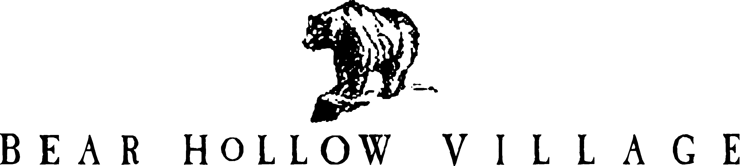

HOMEOWNER’S ASSOCIATION
PARK CITY, UTAH

POLICY STATEMENT

LANDSCAPING SERVICES POLICY

PURPOSE:

This Policy Statement will outline the guidelines established for the landscaping services to be provided to the common areas and to owner’s private property within Bear Hollow Village.

AUTHORITY:

In accordance with Article’s 3.8, 3.14, 3.15 and 3.16, of the Second Amended Restated and Confirmatory Declaration of Protective Covenants, Conditions, and Restrictions for Bear Hollow Village (CCR’s) all Owners and residents are obligated to maintain the appearance of their properties and the Homeowner’s Association (HOA) is obligated to maintain the common areas of the community. The Board of Trustees for the Homeowners Association is empowered to promulgate Rules & Regulations for the regulation of the community and to initiate enforcement actions for violations of the CCR’s and the Landscaping Services Policy.

DESCRIPTIONS OF SERVICES PROVIDED :

TO COMMON AREAS : it is the full responsibility of the Homeowner’s Association to provide landscaping services to all the common areas within the community. The Association will provide all necessary services to maintain the common areas of the community in a safe and attractive appearance. All services to the common area’s will be under the supervision and discretion of the Board of Trustees.

TO OWNERS PRIVATE PROPERTY : it is specifically stated and understood that the primary responsibility for the maintenance, upkeep and appearance of individual owners private property, including those components of the irrigation system located on the private property of an owner, rests with the OWNER of the property.

The Homeowner’s Association, as a cost effective and efficient method for providing services to the entire community, including owners private property, will provide the following specific services to owner’s private property during the Spring and Summer seasons:

- Lawn mowing services on a weekly basis, or less frequently as weather and grow conditions require, in the sole discretion of the Board of Trustees.
- Lawn fertilizing, up to three (3) times per season as conditions require, in the sole discretion of the Board of Trustees.
- Tree spraying / fertilization / maintenance as determined by the sole discretion of the Board of Trustees.
- Weeding of plant beds and mulch areas, and spraying for weeds as determined by the sole discretion of the Board of Trustees.
- Pruning of trees and shrubs as necessary, in the sole discretion of the Board of Trustees.
- General cleanup services as required, in the sole discretion of the Board of Trustees.

The Homeowner’s Association will provide mulch to Owners properties on a bi-annual basis (every other year). Properties north of the Clubhouse will receive mulch in even numbered years and properties south of the Clubhouse will receive mulch in odd numbered years. Mulch will only be provided to the front and / or rear areas of an Owners residence that faces the street. Mulch to areas on the sides of a property are an Owner’s responsibility. Mulching will be provided subject to available funds and at the sole discretion of the Board of Trustees.

The replacement of Dead or Damaged Tree’s, Flowers and / or Shrubs on owners private property is the responsibility of the property owner, with the exception that tree’s, flowers or shrubs damaged by the contracted Landscaping Services provider will be replaced with a similar or comparable item at the expense of the HOA.

The replacement of dead or damaged Grass / Sod areas on owners private property is the responsibility of the property owner, with the exception that grass / sod areas damaged by the
contracted Landscape Services provider will be repaired or replaced at the expense of the HOA.

IRRIGATION SYSTEM SERVICES :

The irrigation system consists of a network of above ground and underground water lines, valves, control boxes, timers and sprinkler heads throughout the community. Parts of the system are located on the exterior , both above and below ground, private property areas of individual owners property and parts of the system are located on interior portions of individual owners property.

The general rules and guidelines for the determination of repair costs and responsibility will be-
- The Homeowners Association will be responsible for repairs and maintenance of the exterior portions of the irrigation system located on the private property areas of individual owners property.

- The Owner will be responsible for repairs and maintenance of the interior portions of the irrigation system located within their units / homes.

- Damages to the irrigation system components caused by the actions of an owner, their tenants or agents, will be the owners responsibility for the costs of repairs to the system.

- In the event of unusual circumstances or repairs to the irrigation system that are required to be performed both to the interior and exterior areas of the system, the Board of Trustees may determine that it is appropriate for the HOA to fund the entire costs of a repair; the decision to fund the entire costs of an irrigation system repair will be based on the specific circumstances present at the time of the repair, the nature of the repair and the cause of the damage, and will be at the sole discretion of the Board of Trustees.

IRRIGATION SYSTEM TURN ON – TURN OFF RESPONSIBILITIES:

The turn on and turn off of the water supply to the irrigation water system is a SHARED
responsibility between the Homeowner’s Association and individual OWNERS. The HOA
cannot and will not enter your private property residence to perform valve turn on / turn off
responsibilities without specific authorization from the Owner and an Agreement in advance by the Association to do so.

The HOA will provide contracted services to start up and shut down the irrigation system as required, at the expense of the Homeowners Association.

The HOA will provide written notice to all owners, to their current address of record, advising them of specific deadline dates for the turn on / turn off of the irrigation system control valves located within their private property residences. Owners who fail to comply with the written instructions and do not turn on / turn off their irrigation system control valves by the specific deadline dates will be responsible for the costs of additional services then needed to turn on / turn off their irrigation system control valves. Owners who fail to comply with the specific
turn on / turn off deadline dates will be charged an expense of $100.00 to cover additional costs associated with servicing their property irrigation system turn on / turn off requirements.

Owners who fail to turn on / turn off their irrigation system control valves by the specific deadline dates will also be totally responsible for any costs for damages or repairs to the irrigation system caused by freezing water conditions.

ENFORCEMENT

Unit Owners in Bear Hollow Village are completely responsible for the actions of themselves, their family members, guests and renters utilizing their Unit or agents of the owner doing repair work or improvements on the property. Enforcement actions by the Board of Trustees will be against the responsible OWNER.

The Board of Trustees are empowered and authorized by the CCR’s to assess fines, suspension of Owner privileges, or any other action deemed appropriate, in their sole discretion, for violations of the Landscaping Services Policy.

Fines, suspensions or other enforcement actions by the Board of Trustees will be commensurate with the type, severity and / or frequency of the violation cited.

This Policy shall become effective AUGUST 15, 2006. Revised April 7, 2021

