Bear Hollow Village
Homeowner’s Association
Policy Statement
No Unsightliness Policy

PURPOSE:

No unsightliness is permitted on or adjacent to any Unit or property in Bear Hollow Village .The objective of this policy is to regulate the overall appearance of Bear Hollow Village for the enjoyment of all homeowners and their tenants or guests.

AUTHORITY:

Article 4.1(q) of the CC&Rs dated March 2004 provides the authority to the Board of Trustees to restrict unsightliness conditions in Bear Hollow Village.

Article 3.16 of the CC&Rs provides the authority to the Board of Trustees to correct certain conditions determined to be unacceptable to homeowners collectively or individually. The reasonable cost to correct these problems can be made part of the Common Area Assessments for an individual Unit if not addressed by the respective Owner/s/ within a reasonable time period as determined by the Board of Trustees.

Fines can be assessed by the Homeowners Association for violations of the No Unsightliness Policy and/or the CC&Rs .

This policy does not apply to the Declarant during the development period.

DEFINITIONS:

Unsightliness - any condition that a reasonable person would find to distract from the overall appearance of Bear Hollow Village.

RULES AND REGULATIONS:

The following unsightly conditions have been predetermined to be prohibited in Bear Hollow Village as outlined in Article 4.1(q) of the CC&Rs.

- open storage of building materials, except during construction of a Unit, or renovations
to a Unit, on the property where the building materials are being temporarily stored.
Building materials stored during the construction phase at any Unit must be maintained
in an orderly manner at all times. All construction debris must be removed from the
property as soon as possible.
- open storage/parking of:
- farm or construction equipment,
- trucks or any vehicles larger than ¾ ton
- inoperable motor vehicles, boats, campers, trailers, snowmobiles, ATVs or
other recreational vehicles
- lawn furniture or garden furniture except during the spring / summer seasons.
- storage of any other material, vehicle or equipment in a manner that is visible by
the public or from another Unit .

- storage of construction or household waste, except construction or household waste put
in tightly closed containers and placed at the curb for disposal in accordance with
scheduled trash collection days.
- storage of any other material, vehicle or equipment in a manner that is visible by the
public or from another Unit is prohibited
- waste containers, other than those placed at the curb the night before scheduled pick-up
and removed within 24 hours after pick-up is complete.

Each Unit/Property Owner is responsible to maintain their Unit and property in a manner that does not create any condition which is considered dangerous, unsightly, unhealthy, unsanitary, or which constitutes a nuisance as described in Article 3.16 of the CC&Rs.

ENFORCEMENT:

Unit/Property Owners in Bear Hollow Village are responsible for the maintenance of their Unit and property, for the correction of any violations brought to their attention, and for any /all Fines assessed by the Homeowners Association for violations of the No Unsightliness Policy and/or the CC&Rs (regardless of whether their property is owner occupied or rented to others).

Unit owners are responsible for providing notification to property management agents, long term tenants or nightly rental tenants of the No Unsightliness Policy in Bear Hollow Village.

Units/ Owners with a non vehicle violation of CC&Rs Article 4.1 (q) will receive a written notice from the Homeowners Association describing the unsightliness violation and an accompanying photograph (if deemed necessary by the Trustees) showing the violation. This notice will request the correction of the violation within 7 calendar days. If this violation continues after 7 calendar days from the date of the notice, the Homeowners Association will assess a fine of $50.00 a day on the property owner until such time as the violation is corrected. The property owner will be notified in writing of the day the fine has commenced and the day the fine ends ( when the violation(s) ceases). The fine/s/ will be included in the owners Common Area dues Assessment and are payable in full.

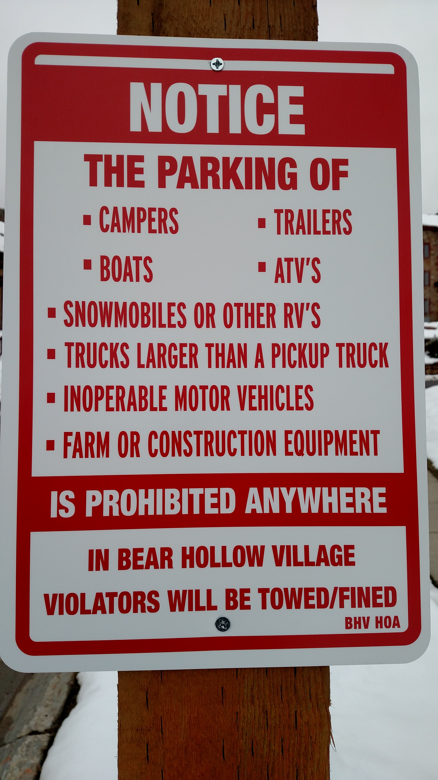
The parking of farm or construction equipment, inoperable motor vehicles, boats, campers, trailers, snowmobiles, ATV's or other recreational vehicles, and trucks larger than pick-up trucks is prohibited anywhere within the Bear Hollow Village Specially Planned Area.

Any of the above vehicles observed parked in Bear Hollow Village will have a Warning Notice placed on the vehicle advising the Owner the vehicle is in violation of the community rules and must be removed from Bear Hollow Village within 48 hours of the posted Notice placed on the vehicle.

A vehicle not removed after the 48 hour warning Notice period will result in the imposition of a fine of $100.00 per day on the vehicle Owner for each day the vehicle remains parked in Bear Hollow Village, or in the case of a vehicle owned by a tenant renting a property in Bear Hollow Village the fine will be imposed on the property Owner where the tenant resides.

The owner/s/ of a Unit in violation of CC&Rs Article 3.16 will receive a written notice from the Homeowners Association describing the violation and an accompanying photograph (if deemed necessary by the Trustees) showing the violation. This notice will request the correction of the problem within 30 days or adequate proof and justification (as determined by the Trustees) as to why the violation cannot be corrected within the 30 days time period along with a corrective action plan describing exactly when the violation will be corrected in the earliest possible timeframe. If there is no evidence or response from an owner receiving notice of a violation to correct the violation, the Board of Trustees will, in accordance with the authority granted by the CC&Rs, complete the repair and/or maintenance deemed necessary to correct the violation. The cost of this effort will then be included in the Common Area dues Assessment for the Unit. There will be an additional service charge of 10% added to the cost of the repair and/or maintenance handled by the Homeowners Association which will also be added to the Unit Common Area dues Assessment and will be payable in full.

This Policy is effective commencing April 1, 2004.

