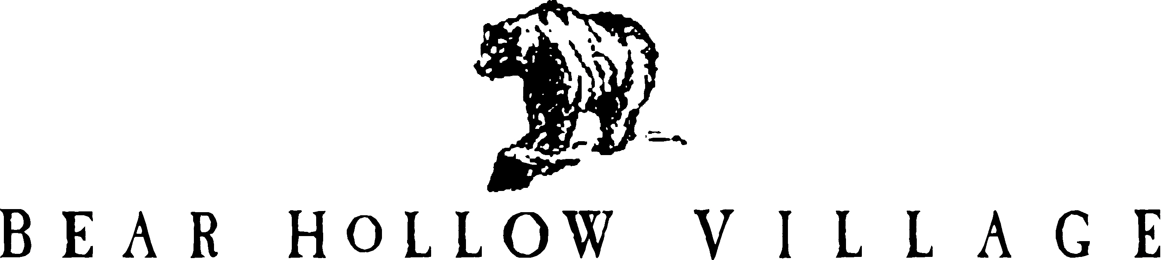

HOMEOWNER’S ASSOCIATION
PARK CITY, UTAH

POLICY STATEMENT

DOGS / CATS - PET POLICY

PURPOSE:

This Policy Statement will outline the guidelines established for the presence of dogs and cats as domestic pets of Owners or Tenants within Bear Hollow Village.

AUTHORITY:

In accordance with Article 4.1.m of the Second Amended Restated and Confirmatory Declaration of Protective Covenants, Conditions, and Restrictions for Bear Hollow Village (CCR’s) the Board of Trustees for the Homeowners Association is empowered to promulgate Rules & Regulations for the regulation of pets in the community and to initiate enforcement actions for violations of the CCR’s and the Pet Policy.

RULES & REGULATIONS

1. Unit Owners or long term Tenants may keep a maximum of 2 dogs or 2 cats, or 1 dog
and 1 cat, as domestic pets within their Unit. No other type of animal as a pet is
permitted within Bear Hollow Village as a domestic pet or otherwise without the
specific approval of the Board of Trustees. This restriction on the number of pets
permitted does not apply to small birds usually kept in cages and tropical fish usually
kept in tanks exclusively inside an owners unit.

2. All domestic pets maintained by Owners or long term Tenants must at all time be in
compliance with all Summit County Ordinances, rules and/or regulations in effect
regarding dogs or cats or other pets as allowed herein.
3. All dogs maintained by Owners or long term renters in Bear Hollow Village must be
annually licensed by Summit County, Utah. Owners are required to provide each dog
with an appropriate collar or harness to which the license tag must be affixed and
constantly worn while the dog is outside the premises of the Owner.

4. No dogs or cats are permitted to run at large or outside the custody or control of the
owner or person having custody and control of the pet. All domestic pets must be on a
leash or have an electronic collar. If an electronic collar is being used the person
having custody of the animal must maintain sight and voice control over the animal at
all times and have a leash with them at all times. A pet wearing an electronic collar
that is not responsive to commands from the person in control of the animal, or is
jumping on or menacing other dogs or people or acting in an inappropriate manner
will be considered off leash and subject to penalties as outlined in this Policy.

5. Owners or persons having custody and control of a domestic pet must clean up all
pet droppings immediately after they are made by the pet and deposit them in an
appropriate trash receptacle, as provided by the Homeowners Association or the
specific Owners trash receptacle, together with any materials used to pick up the
droppings.

6. No domestic dogs or cats are permitted to disturb the peace and quiet of the
neighborhood / community by barking or howling for an extended period of time.

7. No pets are permitted to be left unattended or confined in a vehicle without adequate
ventilation or foe an unusual length of time while said vehicle is parked in any
common area of Bear Hollow Village. An unusual length of time is defined as more
than 15 minutes.

8. No pet can be tied or chained to any common area facility under any circumstances or
for any period of time while in Bear Hollow Village.

9. Short term tenants / nightly renters are not permitted to keep dogs or cats in rented
units at any time. A short term tenant is defined as a tenant renting a unit for less than
30 days.

10. A long term tenant is defined as a tenant renting a unit for 30 consecutive days or
longer.

ENFORCEMENT

All enforcement actions for violations of the Pet Policy and / or CCR’s will be enforceable by the Homeowner’s Association against the Unit Owner
responsible for the pet; the pet’s owner, or against the Owner with regards to a long term tenant pet violation.

An owner or person having custody and/or control of a domestic pet observed or otherwise documented to be in violation of any of the enumerated Rules & Regulations of the herein described Pet Policy as a FIRST OFFENSE will result in the Owner being fined $100.00 and have owner privileges suspended for 30 days by the Board of Trustees. Owners in violation of the Pet Policy will receive a written Notice identifying and describing the specific violation cited.

An owner or person having custody and/or control of a domestic pet observed or otherwise documented to commit a SECOND OFFENSE of any of the enumerated Rules & Regulations of the herein described Pet Policy will result in the Owner being fined $250.00 and have owner privileges suspended for 60 days by the Board of Trustees. Owners in violation of the Pet Policy will receive a written Notice identifying and describing the specific violation cited.

An owner or person having custody and/or control of a domestic pet observed or otherwise documented to commit a THIRD OFFENSE of any of the enumerated Rules & Regulations of the herein described Pet Policy will result in the Owner receiving a Third and Final Notice of Violation from the Board of Trustees identifying and describing the specific violation cited and declaring the pet to be considered a nuisance and declaring it must be removed from the community immediately. A fine of $500.00 and a suspension of owner privileges for 90 days will also be imposed on the Owner.

An Owner who refuses to remove a pet declared a nuisance from the community will be subject to a fine of $50.00 per day for each day or part thereof that the nuisance pet is not removed from the community, commencing on the date of the Notice declaring a Nuisance Pet, and further legal actions by the Homeowners Association as the Board of Trustees deem appropriate, and suspension of all other Owner privileges until such time as the nuisance pet is removed from the community.

An Owner who permits a short term tenant / nightly renter to have pets in their Unit, in violation of the Pet Policy, will be fined $500.00 by the Board of Trustees, be ordered to immediately have the tenants remove the pet from the community, and the owners HOA privileges will be suspended for 180 days commencing on the date of the removal order.

Any violation of the Pets Policy involving a dog biting another dog or a person will result in fines being DOUBLED against the Owner for the violation.

The Board of Trustees also reserve the right to modify / increase / decrease / suspend any fines or other penalties enumerated in this Policy, in their sole discretion, as specific circumstances of an event may require.

All monetary fines assessed against an Owner for violations of the Pet Policy are
deemed to be payable in full when recorded to their accounts and billed to the owner.

This Pet Policy shall become effective MAY 15th, 2006.
Revised/ revisions effective April 20, 2020.

