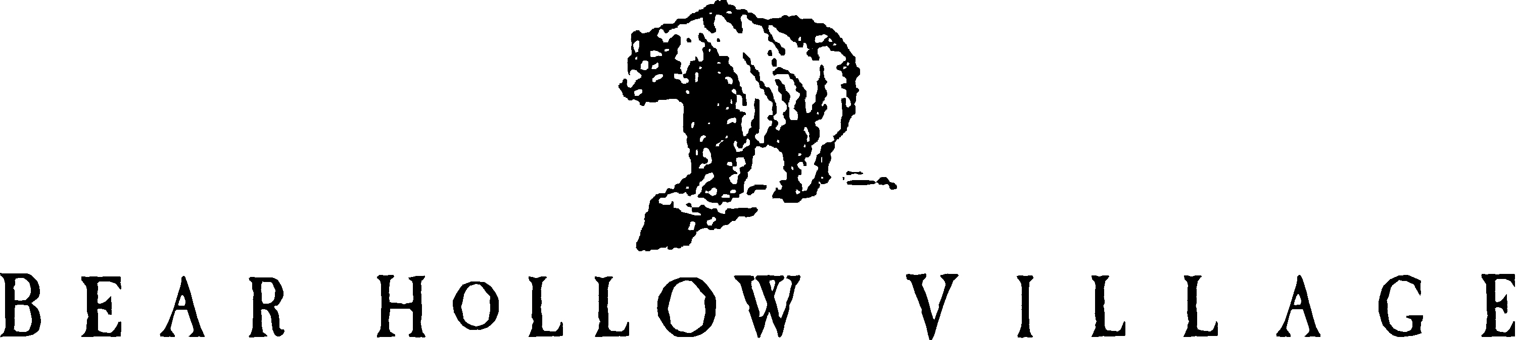

HOMEOWNER’S ASSOCIATION
PARK CITY, UTAH

HOA REINVESTMENT FEE

The Bear Hollow Village Homeowners Association collects a Reinvestment Fee from the buyer for the Association expenses when a property sells. The fee is one quarter of 1% (.0025) of the unit final sales price as listed on the real estate sales contract.

FINAL SALES PRICE ___________________________

X .0025

HOA REINVESTMENT FEE __________________________________

The fee is the personal obligation of the buyer and constitutes an assessment for which the Association has a lien against the property. The Association has the right to record a notice of lien against the property and pursue collection of the fee if it is not paid to the Association at closing. The property may be exempt from the HOA Reinvestment Fee if any of the following conditions are applicable to the sale: INITIAL next to the exemption being claimed, if any.

- ________ The property is designated as a Summit County, Utah deed restricted /
affordable housing unit.

- ________ The property is being transferred under a Will, Trust or other probate
instrument.

- _________ The property is the subject of a foreclosure or the property is owned and sold
by a bank or other financial institution.

- _________ The property is being refinanced by the current owner or is a transfer of convenience between related parties, such as a change in name for an LLC, adding or deleting a partner in the LLC or similar entity, is being performed.

- _________ The property is being sold or transferred to an owner’s spouse, parent, child, sibling, grandchild, grandparent, aunt, uncle, cousin, niece, nephew, great grandparent or great grandchild.

If you are claiming an exemption under condition 2 please attach documentation to identify the will, trust or probate instrument.

If you are claiming an exemption under condition 3 please explain the foreclosure or bank involvement.

If you are claiming an exemption under condition 4 please explain the refinance or transfer of convenience circumstances and attach all relevant documentation and information.

If you are claiming an exemption under condition 5 please explain the specific relationship between buyer and seller.

_______________________________________________________________________________

_______________________________________________________________________________

_______________________________________________________________________________

_______________________________________________________________________________

_______________________________________________________________________________

_______________________________________________________________________________

____________________________ __________________________
Signature of Buyer Date

____________________________________________
Property address

