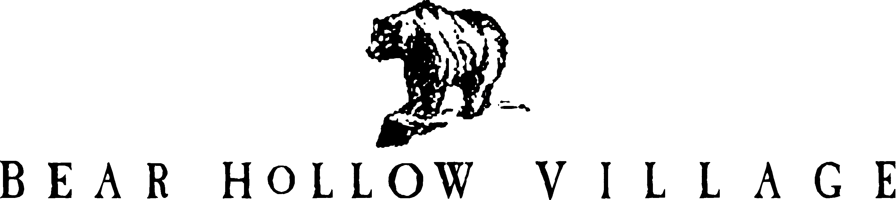

HOMEOWNER’S ASSOCIATION
PARK CITY, UTAH

POLICY STATEMENT

ASSOCIATION / CORPORATION RECORDS
REVIEW POLICY

PURPOSE:

This Policy Statement will outline the guidelines established for the review of the Association
corporate and/or business records by the membership of the Bear Hollow Village Homeowners Association.

AUTHORITY:

In accordance with Article IV and Article IX of the By-laws for the Bear Hollow Village Homeowners Association the Board of Trustees are empowered to promulgate Rules & Regulations for the management of Association business matters.

The Bear Hollow Village Homeowner’s Association (HOA) is a not for profit corporation registered as such in accordance with the laws of the state of Utah. All requests for review of HOA records will be regulated in accordance with Utah Code 16-6a et seq.

GUIDELINES:

Association business records and corporate records are maintained at the Association office located in the Clubhouse building in Bear Hollow Village, 5522 N. Lillehammer Lane, Park City, Utah 84098.

Association members are requested to make requests in writing, via signed correspondence to the Association President, to view the HOA business and corporate records, in accordance with the provisions of Utah statutes Chapter16-6a-et.seq. and Chapter 57-8-17 et.seq. and Association guidelines.

Members requesting copies of any Association records may be charged a reasonable fee covering the costs of labor and material for copies of any documents provided, at the discretion of the Board of Trustees. Any fee imposed is deemed to be payable upon receipt.

No Association records maintained at the Clubhouse Association office may be removed from the office without the specific written authorization of the Board of Trustees.

The Association also maintains a website, www.bhvhoa.com , where many HOA corporate and/or business records are posted for the information and review of the membership and the general public.

Association records maintained on the HOA website are available in electronic format at any time for viewing or downloading.

ENFORCEMENT:

Any person who attempts to alter, destroy, tamper with or remove Association records from the
Office of the Association in violation of this Policy will be charged with any / all appropriate offenses under Utah state laws and prosecuted to the full extent of such laws.

Any Member of the Association who attempts to alter, destroy, tamper or remove Association records from the Office of the Association in violation of this Policy will also have their Association rights in all HOA matters suspended immediately.

Members who request copies of any Association records and who are charged a fee for those records as stated herein are responsible for the payment of said fee within 14 days of billing.
Members who fail to pay the fee billed will be prohibited from requesting any additional copies of HOA documents until the pending fee is paid in full. The Association also reserves the right to pursue any other appropriate collection actions for any unpaid fee imposed on a member.

This revised Policy shall become effective January 1, 2017.

