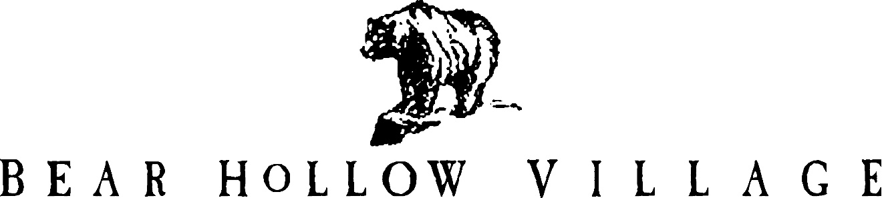

HOMEOWNER’S ASSOCIATION

PARK CITY, UTAH

NEWSLETTER

SPRING 2019

This is the 44th edition of the Bear Hollow Village Homeowner’s Association Newsletter brought to you by your Board of Trustees. This Newsletter will provide you with an update on things happening in our community and other information.

**\*\*\*\*\*\*\*\*\*\*\*\*\*\*\*\*\*\*\*\*\*\*\*\*\*\*\*\***

**WINTER SEASON ENDS**

It has finally stopped snowing (we think!) and we are recovering from a heavy snow winter season. Several properties in the community sustained damages to their roofs and gutter / downspouts from ice dams, drainage problems and snow accumulation. We also had to bring in heavy snow removal equipment and dump trucks to remove snow from roads / intersections / parking areas to maintain community safety and facilitate safe travel.

The HOA recommends that all owners take this opportunity to evaluate their homes safety and winter readiness, and make repairs as needed. Here are a few suggestions to consider…..

* Add heat tape/ice melt panels to roof edges and gutters/downspouts
* Check attic areas to ensure roofs are properly ventilated (to prevent ice dams)
* Have your sprinkler system checked and serviced to make sure it is properly filled with

anti freeze substance and working properly (this may be an insurance policy requirement and if not done it may void your policy – check with your agent.)

Townhouse owners are reminded that the HOA does not provide any insurance coverage to any portion of your building or individual unit. The HOA only insures the common areas of the community – there is no common area in a townhouse building – everything is someone’s private property and must be insured accordingly.

**CLUBHOUSE**

Since transitioning to a monthly (vs. quarterly) preventive maintenance schedule the gym exercise equipment is holding up much better.

There are no issues/ problems in the Clubhouse that we are aware of at this time, which is a good thing.

**The pool is scheduled to open for the season on May 22. Yes, the pool is heated !**

**LANDSCAPING SERVICES**

We have started cleanup from the winter and it is also time to turn on the irrigation system.

All owners that have an irrigation control valve inside their homes have received a separate Notice asking them to turn on the valve so we can make repairs as needed and service the lawns and shrubs.

All lawn areas are scheduled to receive an aeration followed by a fertilization shortly.

**PARKING RULES**

We have parking rules to ensure the safety of the community. Signs are posted on all

roadways advising what the parking rules are for that area. Owners are also reminded it is

a violation of the parking rules, and the Summit County Parking Ordinance, to leave vehicles

parked unattended in the same location for more than 72 hours. The HOA does not like to have to tow a vehicle, but we also cannot permit vehicles parked in clear violation of parking rules to remain in their location. We take all reasonable measures to attempt to locate a vehicle owner

before towing, which is a last resort. However, any vehicle creating a safety concern will be towed immediately.

Also, please be reminded that Bobsled Blvd. and Oslo Lane are County roads and the Sheriff

enforces parking rules on those streets; all other roads in the community are private roads controlled by the HOA.

All community parking rules and regulations can be viewed on our website www.bhvhoa.com

PLEASE obey the parking rules !

**ROADWAYS – POTHOLES**

We have identified 20 areas on our private roads that need repairs / potholes filled and we have contracted with Big Red Paving to make these repairs as soon as possible. (this is their busy season and we are on the list for repairs). Bobsled Blvd. and Oslo Lane are Summit County maintained roads and we are contacting them to check on status of repairs to those roads.

**ASSOCIATION FINANCES**

We are in excellent financial shape. We have the following funds on deposit with Chase Bank-

RESERVE FUNDS - $ 420,551.76

EMERGENCY FUNDS - $ 50,403.36

CHECKING ACCOUNT - $ 58,384.73

TOTAL FUNDS (as of 4/19/2019) **$ 529,339.85**

**PAYING YOUR DUES**

In an effort to increase efficiency and offer more options and convenience to the members, the HOA established a LOCKBOX account with Chase Bank in January 2017 for the receipt of dues payments. ALL dues payments should be sent to the LOCKBOX at the below address….

**BEAR HOLLOW VILLAGE HOA**

**DEPT. # 880151**

**P.O. BOX 29650**

**PHOENIX, AZ 85038-9650**

There are still a few owners who have not transitioned to the new Lockbox address for their dues payments. Please send all payments to the Lockbox address !

Please be sure that you use the address **EXACTLY** as shown for mailing dues payments – do not forget to include the Dept. # 880151 information in the address.

In addition, the HOA offers owners the options to pay their dues Annually – Semi-annually –

Quarterly – or Monthly. And, we can EMAIL your dues Invoice to you if you prefer that option

Instead of regular US mail. Please email Howie if you would like to change your dues payment

option or switch to email Invoices - [www.hb2690@aol.com](http://www.hb2690@aol.com)

**HOA DESIGN REVIEW COMMITTEE**

Please be reminded that anything that will change the exterior of your property must be submitted to and reviewed / approved by the HOA Design Review Committee (DRC) as a first step. Send information describing the proposed project to any of your Trustees for processing by the DRC.

**PROPERTY MAINTENANCE - UNSIGHTLINESS**

All Owners are reminded that the community rules (the CCR’s) require you to maintain the exterior of your property to acceptable / reasonable standards at all times. Decks – railings – logs need to be cleaned and re-stained to preserve their lifespan and appearance.

Building exteriors also need refinishing / cleaning on a periodic basis. The Trustees inspect the community periodically to ensure all properties are in compliance. When a property is noted to be falling into disrepair the owner will be notified accordingly. We request that all owners be

pro-active in their maintenance responsibilities – to avoid possible fines and suspensions of owner privileges.

*******************************

Please enjoy our amazing community and its amenities. Summer season is near and it will soon be barbecue time ! Your HOA Board of Trustees !

GREG DAVID JODY HOWIE SUSAN

MCj04360010000%5b1%5d MC900439945%5b1%5d MCj03474450000%5b1%5d **MCj01986060000%5b1%5d** 

PLEASE VISIT OUR WEBSITE

[WWW.BHVHOA.COM](http://www.bhvhoa.com/)

FOR COMMUNITY INFORMATION AND ANNOUNCEMENTS