

HOMEOWNER’S ASSOCIATION

PARK CITY, UTAH

NEWSLETTER

SUMMER 2022

This is the 51stedition of the Bear Hollow Village Homeowner’s Association Newsletter brought to you by your Board of Trustees. This Newsletter will provide you with an update on things happening in our community and other information.

**CLUBHOUSE / VILLAGE GREEN**

Earlier this month, the Summit County Health Department conducted its Annual inspection of the Clubhouse. The inspection ensures that we are in compliance with all applicable health and safety codes currently in effect. The pool and hot tub water content is tested. Grab rails, ladders, step rails, safety equipment, drains, walkways and lounge areas are all checked.  
Chemical storage areas and signage, bathroom facilities and our maintenance and chemical monitoring records are all inspected. **We passed all inspections with a perfect score !** The inspector commented our Clubhouse facilities were the “easiest inspection he has ever done”.

On behalf of the community, THANK YOU to Greg our Clubhouse Manager for a continuing job well done!

We completed the refinishing of the pool and hot tub concrete perimeter areas and they look really nice. Here are some photos…………..

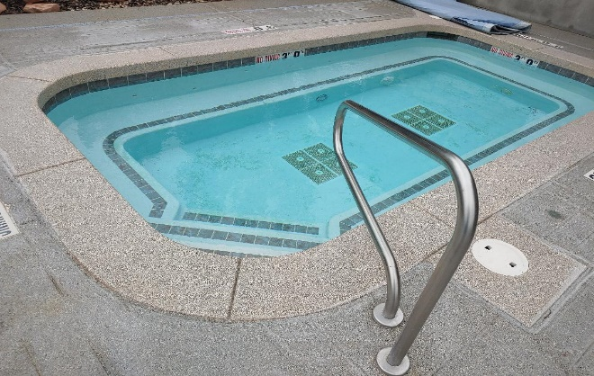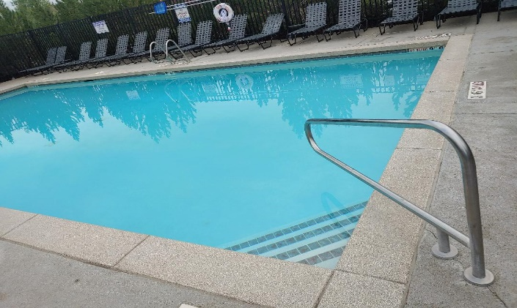

**The pool will close for the season on SEPTEMBER 19TH**

The hot tub remains open all year long, weather permitting.

The two barbecue grills on the patio areas in the Village Green are used heavily.

We brought in a professional grill cleaning company to do a deep clean of the grills inside and outside. They came out looking real good. We also replaced the ignition switches on each grill that were malfunctioning. Here are photos…..

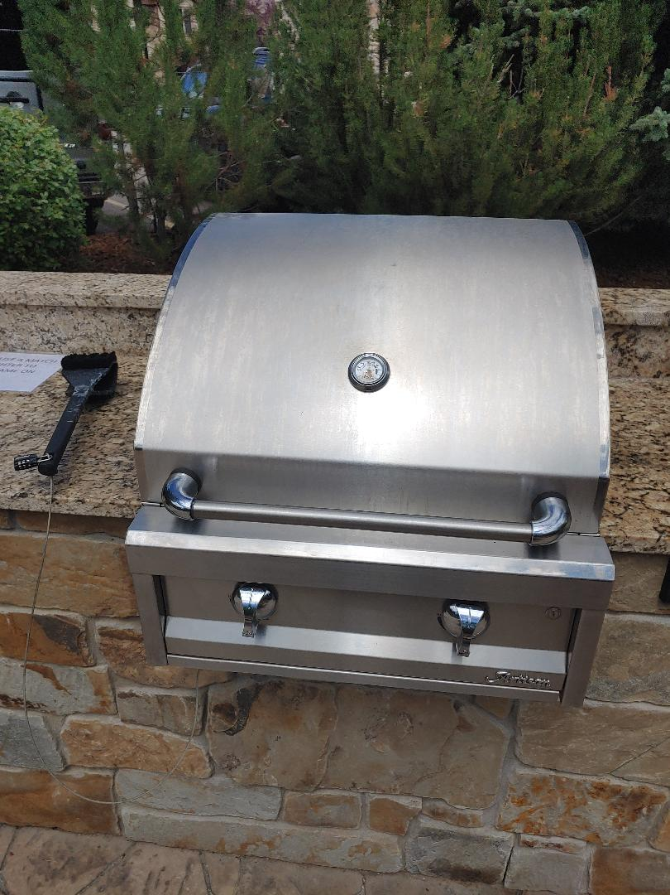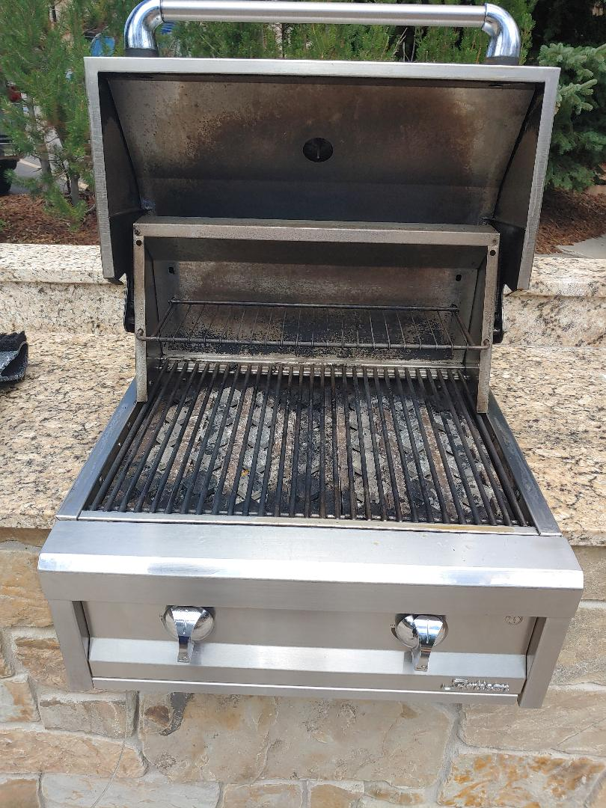

**The barbecue grills will close for the season on OCTOBER 3rd**

In the Spring 2022 Newsletter we reported that a Coca Cola area vendor would be installing a Coke machine in the Clubhouse. Subsequently, they advised us that they were unable to secure a machine and could not do the installation as promised.

Our snack machine vendor was contacted and he was able to provide us with a

Pepsi vending machine – but we also sell Coke products from it.

Coke or Pepsi - the choice is yours !!



**ASSOCIATION FINANCES**

We remain in excellent financial condition and have the following funds on deposit with Chase Bank, as of September 9, 2022 :

RESERVE FUND SAVINGS ACCOUNT $ 365,103.51

EMERGENCY FUND SAVINGS ACCOUNT $ 50,469.80

CHECKING ACCOUNT (operating capital) $ 15,753.17

TOTAL $ 431,326.48

**ROOFING**

Most of the single family detached homes, townhouses and condominiums on the South side of the community were built in 1999-2000 by the original developer. If your home has cedar wood exterior it is a unit built in that time frame. Homes built by the second developer, Hamlet Homes, have a concrete material (hardy board) exterior and were built in the 2004-2006 timeframe.

The roofs on the original developer homes are 22-23 years old and near the end of their lifespan.

Our hard mountain climate and 7,000 ft. elevation take a heavy toll on building exteriors and roofs. Several owners have already reported roof problems.

The HOA recommends that owners evaluate their roof and start to make plans now for replacement. Townhouse and condominium owners will need to work with their neighbors sharing their building so that the entire building can be done at the same time.

There have been several new building code requirements for roofing enacted by Summit County since 1999-2000 that now require new roofs to have ice and water shielding in eaves and roof valleys, drip edging protection and other safeguards.

The approximate price to install a new roof on a 5 unit townhouse building is in the $40,000.00 +/- range, to be cost shared by the owners in that building. That is a lot of money! Owners need to get together and plan for this expense now, before a failed roof creates more costly

repairs and expenses for you. The HOA will assist in getting owners in a townhouse building

together to discuss how to proceed, but the responsibility to select a contractor, schedule the work and pay the expenses rests with each owner.

Contact Howie for owner information as needed and help with coordination of a roofing project.

Doing nothing would not be a good option.

**IRRIGATION SYSTEM TURN OFF**

We will be turning off the irrigation sprinkler system to prepare for winter. All single family detached homes and those townhouses that have a master irrigation control valve inside their home need to **turn the valve off by October 3.** The HOA will send a Notice to all homes with a valve that needs to be turned off. Follow the instructions on the Notice received if you need help. If you do not receive a Notice you do not have a valve to close.

**ANNUAL MEETING**

Our 2022 Annual Meeting will be on Monday night December 5. 2022. We will again host the meeting via a Zoom webinar. You will receive more detailed information on the Annual Meeting later this year – this is just an advance notice.

The Annual Meeting will include the election of two HOA Trustees. Any owner wanting to be considered for election to the Board of Trustees should make their intentions known in accordance with the Trustee Election Guidelines accompanying this Newsletter.

**REMINDERS**

**PETS POLICY**

The Summit County Animal Control Ordinance and the HOA Pets policy require that all pets be under the control of their responsible person while outdoors. Pet droppings MUST BE PICKED UP immediately after they are made.

In addition, the community rules limit the number of dogs or cats allowed in a property to two (2). Short term / Nightly renters (renting less than 30 days) are prohibited from having pets at any time.

The HOA will impose severe fines on any Owner identified as being in violation of the Pets Policy.

**DRIVE SAFELY**

School is in and our kids are out and about. PLEASE drive slowly and safely. Be reminded that the speed limit on all our private roads is 15 MPH !

**PARKING RULES**

All of our community parking rules are posted on our website [www.bhvhoa.com](http://www.bhvhoa.com) and signs are posted advising you where parking is not permitted. We do not like to tow away vehicles and we take all reasonable steps to attempt to notify the owner of a vehicle parked in violation of a parking rule. However, any vehicle illegally parked so as to create a safety hazard will be towed away immediately. Please make sure your guests / property managers, renters are aware of the community Vehicle Rules and Regulations.

**NOISE ORDINANCE**

The Summit County Noise Ordinance 5-3-1 and the community rules prohibit the creation of unreasonable noise after 9PM. Any property creating unreasonable noise after 9PM in violation of the Ordinance that results in a Sheriffs Deputy having to respond will be subject to a fine imposed by the Board of Trustees and suspension of owner privileges as deemed necessary.

Please ensure that any renters in your property are aware of the Ordinance. YOU are responsible

for their actions while they are in the community.

******************************************

Please enjoy our amazing community and its amenities. Winter season is fast approaching and snow will be falling – hopefully just on the slopes and not in our driveways !

Please stay safe and healthy and continue to practice social distancing.

Your HOA Board of Trustees!

GREG JODY HOWIE KAREN JOHN

MCj04360010000%5b1%5d MCj03474450000%5b1%5d **MCj01986060000%5b1%5d**



[This Photo](http://www.dpti.sa.gov.au/livingneighbourhoods/making-it-happen/action-planner) by Unknown Author is licensed under [CC BY](https://creativecommons.org/licenses/by/3.0/)



[This Photo](https://opentextbc.ca/abealf2/chapter/chapter-1/) by Unknown Author is licensed under [CC BY](https://creativecommons.org/licenses/by/3.0/)

PLEASE VISIT OUR WEBSITE

[WWW.BHVHOA.COM](http://www.bhvhoa.com/)



HOMEOWNER’S ASSOCIATION

PARK CITY, UTAH

POLICY STATEMENT

TRUSTEE ELECTION GUIDELINES

**PURPOSE:**

The following Guidelines for the election of Trustees are hereby established.

**AUTHORITY:**

In accordance with the Association By-Laws and Article 3.3 et.seq. of the Second Amended Restated and Confirmatory Declaration of Protective Covenants, Conditions, and Restrictions for Bear Hollow Village (CCR’s) the Board of Trustees for the Homeowners Association is empowered to promulgate Rules & Regulations for the proper and safe management of the community.

**THIS POLICY HEREBY ESTABLISHES THE FOLLOWING GUIDELINES FOR TRUSTEE ELECTIONS:**

* The HOA Board of Trustees is currently comprised of five members. In accordance with the CCR’s Trustees are elected for a two year term of office.

Trustee elections are staggered so terms of office do not all expire in one year.

* Trustee elections are held at the Annual Meeting of the Homeowners Association convened in early December (or any adjournment thereof).
* The HOA will announce Trustee vacancies in the Summer Newsletter sent to all Owners in the month of September.
* Owners seeking election to the Board of Trustees will be invited to send to the HOA President a notice of intent to seek nomination at the Annual Meeting. The notice must be received by the HOA President no later than October 15. A notice of intent sent / received after the cut off date will not be accepted / honored.
* Owners seeking election to the Board of Trustees can submit a brief statement of their qualifications or any other information they want mentioned on their behalf with regards to their candidacy for Trustee with their notice of intent. The information submitted must be received by the HOA President no later than October 15. Information sent / received after the cut off date will not be accepted / honored.
* Statements/information submitted by Trustee candidates must be submitted on plain white bond paper – size 12 font (any style) double spaced – 1 inch margins all around - maximum 1 page standard letter paper size. Statements / information

not submitted in accordance with these guidelines will be rejected.

* At least 30 days prior to the announced Annual Meeting date, the HOA will send all Owners in good standing a Notice of the Annual Meeting date and information on Trustee vacancies for that year.
* The Notice will include a Proxy Form for Owners to use to express their voting preference(s) for Trustee election and other matters. All candidates who have made their intention to run for Trustee known to the HOA by the October 15 deadline will be listed on the Proxy Form.
* The Notice of Annual Meeting sent to all Owners in good standing will also include any biography/information statements received from candidates in accordance with the guidelines established herein.
* Proxy forms submitted by Owners expressing their voting preferences for Trustee vacancies and any other matters listed on proxy form must be submitted to the HOA in accordance with the instructions noted on the proxy form.
* A Trustee voting form will be made available for all Owners attending the meeting in person. In person voting forms will supersede any prior proxy submitted by the Owner.
* At the Annual Meeting, one of the current Trustees not seeking election will preside over that portion of the Annual Meeting dealing with Trustee elections.
* At the Annual Meeting, all candidates for Trustee election must have their name placed into nomination by themselves or an Owner in good standing and seconded by an Owner in good standing.
* Any member of the HOA / Owner seeking candidacy for a Trustee position that has not previously submitted their name and biography/ information to the HOA for inclusion on the proxy voting form sent to all Owners prior to the Annual Meeting, or listed on the in person ballot, may have their name placed into nomination and be considered for election, but they have no recourse to request new proxy voting forms be created and sent to Owners which would include their name/information or to request any proxy not containing their name be voided.
* The Trustee presiding over the election will collect all ballots submitted by Owners in attendance at the meeting and all proxy forms sent in according to

the guidelines established for the election.

* The presiding Trustee will also solicit the assistance of another Owner in good standing to act as an independent observer to assist with the review and counting of all voting forms and proxy forms received.
* The presiding Trustee and assisting Owner will count all votes received and submit the results to the Board of Trustees along with a certification that all vote

ballots and proxy forms were reviewed and counted in a fair and impartial manner.

* The Board of Trustees will post the results of the Trustee election, within 24 hours of their receipt, on the HOA Clubhouse bulletin board and within 72 hours on the “Announcements” page of the HOA website.

These guidelines are hereby enacted and effective September 1, 2017.