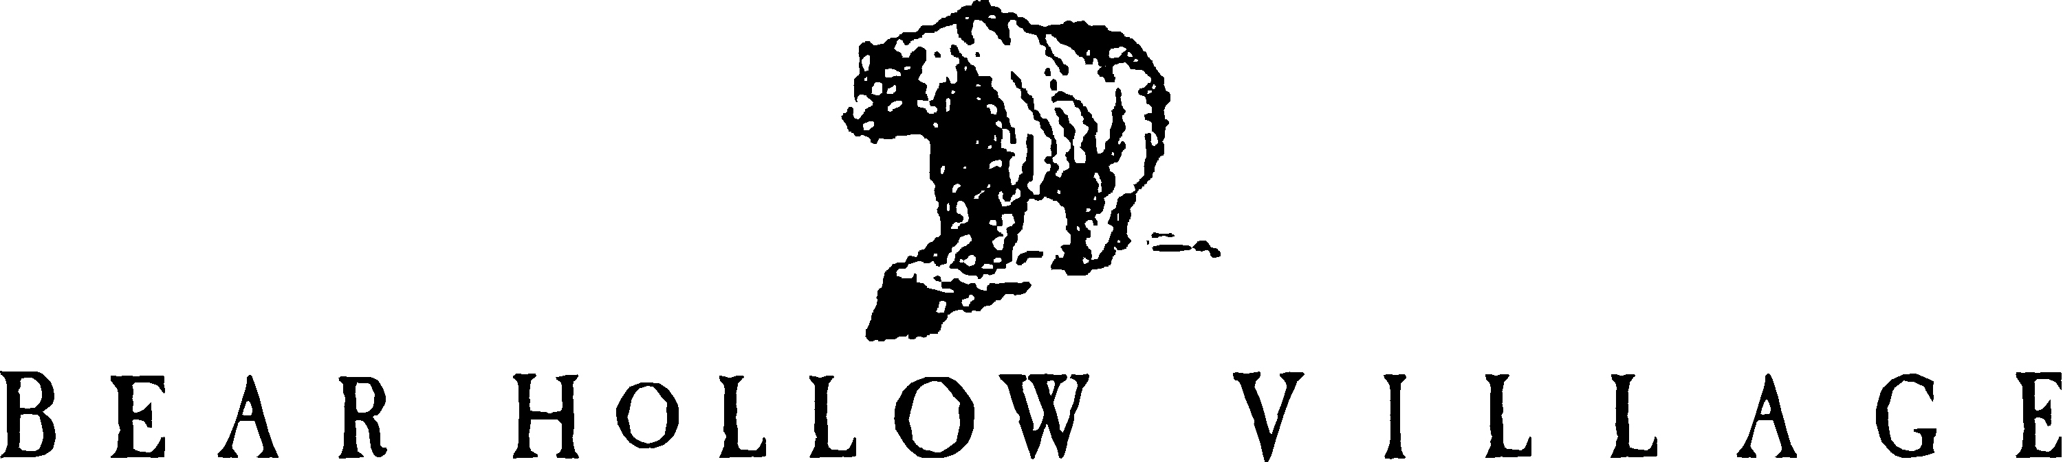

HOMEOWNER’S ASSOCIATION
PARK CITY, UTAH

TRUSTEE CONFERENCE CALL – September 9, 2020
MINUTES

A Conference Call meeting of the Bear Hollow Village Board of Trustee’s was convened at 8:30PM MST on Wednesday September 9, 2020. Trustee’s Jody Lodrick, Greg Watkins, Susan Worthington, Doug Wagner and Howie Butt were in attendance.

The following topics were discussed by the Trustees and are summarized as follows:

Covid 19 issues and Clubhouse - discussion on whether or not to open the hot tub during this time of year when there is no staffing. An option to open with reduced capacity was discussed but not agreed upon. It was the unanimous consensus of opinion that we should opt on the side of caution and not open the hot tub until December when staffing will be on duty.

Current HOA Policies were discussed – and the need for a general Code of Conduct Policy to allow enforcement of unruly and nuisance behavior not covered elsewhere was discussed - each Trustee will independently gather their thoughts and suggestions for a second discussion on this topic in the near future.

The venue for the 2020 Annual Meeting was discussed – it is tentatively scheduled for the Clubhouse on December 7 – capacity 50 people should be sufficient to handle the anticipated attendance – we can review later this year
if conditions change.

With no other business to discuss, the conference call was adjourned at
9:15 PM MST.

