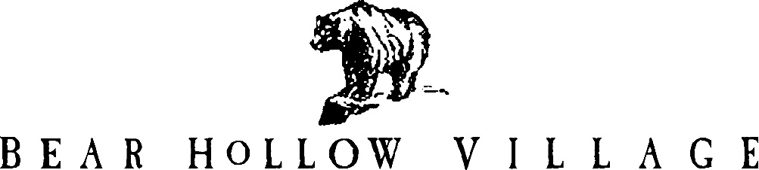

HOMEOWNER’S ASSOCIATION
PARK CITY, UTAH

TRUSTEE MEETING February 17, 2020
MINUTES

The Bear Hollow Village Board of Trustee’s convened a Meeting on Monday February 17, 2020 at 6:30PM in the Clubhouse. Trustee’s Greg Watkins, Doug Wagner and Howard Butt were in attendance.
NOTE: Howie spoke with Trustee’s Susan Worthington and Jody Lodrick
before the meeting to get their input on the meeting discussion items.

Howie provided a financial review of Association accounts. We have the following funds in our banking accounts as of February 16, 2020:

Reserve Funds $ 468,843.14
Emergency Funds $ 50,441.49
Checking Account $ 67,967.47

TOTAL $ 587,252.10

The Budget to date was reviewed; all bills are paid and there are no fiscal concerns for the community at this time.

Howie reported that we have more funds than usual in our checking account due to the fact several owners pay their dues in full at the beginning of the year. A reserve fund contribution of $18,000.00 has also been deposited into our reserve account for this year.

The HOA remains financially solid.

The following issues were discussed regarding the Clubhouse:

- The gym, mens room and ladies room need repainting. We will also replace or repair the metal lockers in each room since they are rusting. Howie will research options.
- Discussion on adding a sauna to each bathroom was held; it was the consensus this is not a cost effective or viable option.
- The exterior stone columns are deteriorating again – we need to explore other options to repair them – Greg will research this.
- We need to replace the free weights since they are deteriorating.
Doug will research options to replace them with rubber weights.
- We will need to replace the pool solar cover blankets and the reel.
- The posters/wall art in the bathrooms need to be replaced.
- We will post the Gym Rules in gym area - Doug creating a poster.

Howie suggested that we also need to refinish the wood columns by the mail kiosk and the railings at the Bobsled Bridge. We will incorporate these projects with the Clubhouse painting projects.

We are planning to resurface / refinish our private roads in the community during the Spring. Vendor bids were reviewed and Big Red Paving is the
low bidder. They have also done repair work in the community in the past and work was performed satisfactorily. We will need to coordinate this project with them so that disruption to community residents is minimized.

Howie advised that several signs in the community need to be replaced. He will order the signs and get them installed.

Snow removal services were discussed – there are no issues and service is very good.

Hosting a summer barbecue for the community was discussed. It is the consensus that not enough owners attend these HOA events to make them cost effective.

Howie asked the Trustees to increase their inspections of the community to note Unsightliness Policy violations, parking problems, street light issues, check condition of the flags on poles by mail kiosk and report any problems to him.

With no further business to discuss, the meeting was adjourned at 7:25 PM.

